1. Leaving Ri (R2) at the default resistance of 1000 ohms, the value of Rf (R3) was calculated using the target gain $A= -10$ in the inverting amplifier formula $A=\frac{-R_{f}}{R_{i}}$. Rewriting it as $R_{f}= -AR_{i}$, Rf was determined to be 10000 ohms. A stabilizing resistor (R1) was then set to the parallel resistance between R2 and R3, which was about 909 ohms.

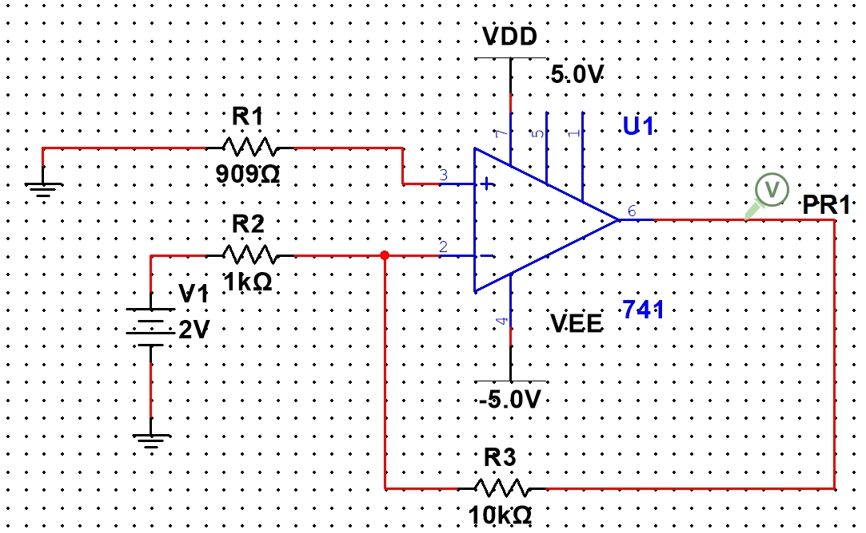

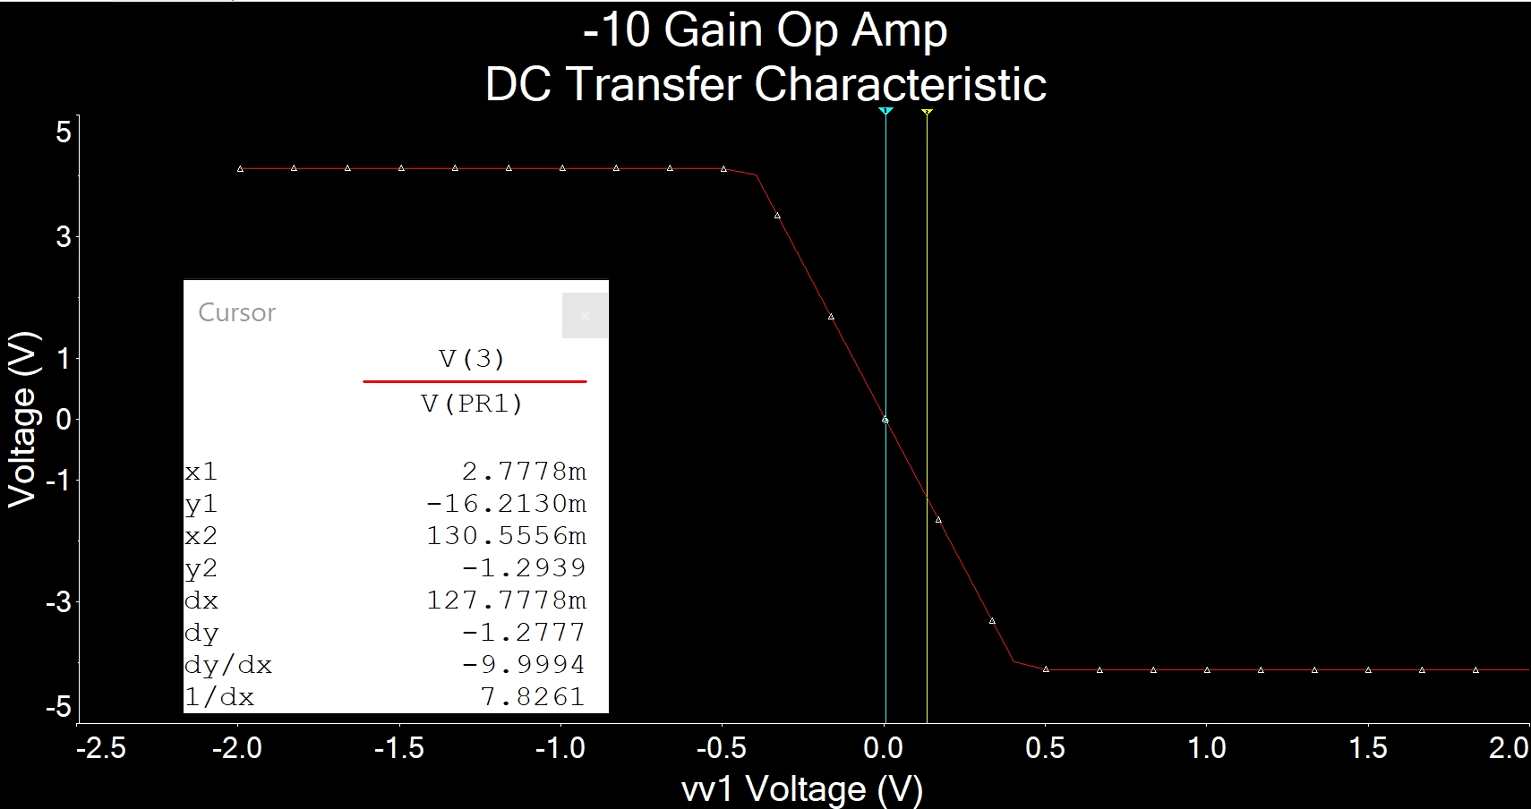

dy/dx is about -10.

2. Still leaving Ri (R2) at the default resistance of 1000 ohms, the value of Rf (R3) was calculated using the target gain $A= -10$ in the non-inverting amplifier formula $A=1+\frac{R_{f}}{R_{i}}$. Rewriting it as $R_{f}= (A-1)R_{i}$, Rf was determined to be 9000 ohms. A stabilizing resistor (R1) was then set to the parallel resistance between R2 and R3, which was 900 ohms.

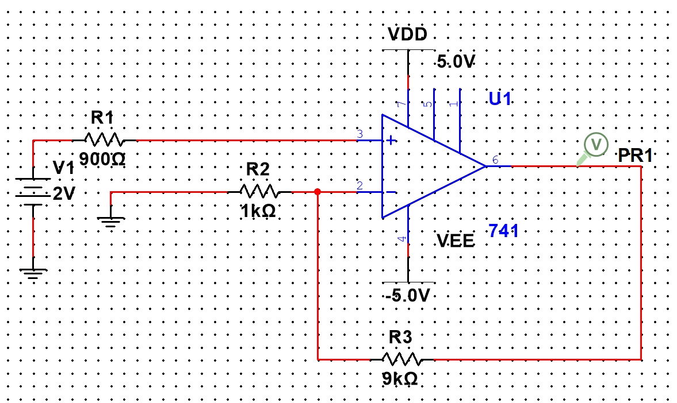

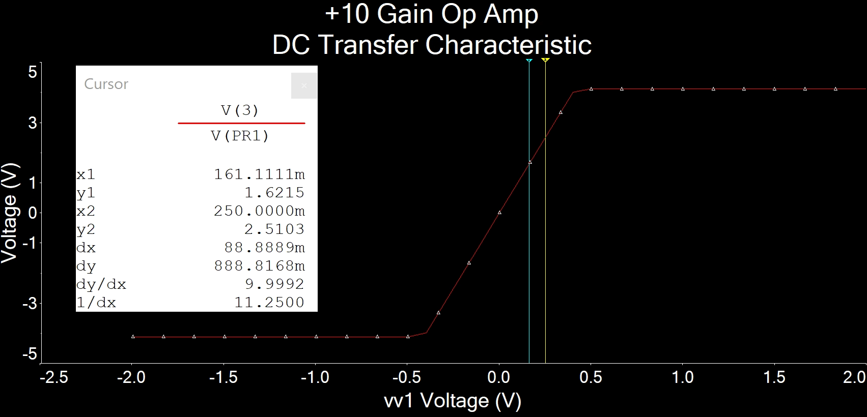

|dy/dx| is about 10.